**SCE SUBMISSION**

**Analog and Digital Electronics**

**[PATTERN 2018]**

**Second Year Bachelor of Technology**

AY-2020-21, Sem-III

Course Teacher

**Mr. Pawan Wawage**

Head of Department

**Prof.(Dr.) Pravin Futane**



Department of Information Technology

VISHWAKARMA INSTITUTE OF INFORMATION TECHNOLOGY, PUNE

(An Autonomous Institute Affiliated to Savitribai Phule Pune

University)

**Index:**

1. Topic Discussion
2. Components
3. Circuit Diagram
4. Implementation
5. Working
6. Conclusion
7. References

**Social Distancing Detector System**

**Using Arduino**

**Title :** Social Distancing Detector System

**Group Members:**

232069 Namrata Thakur

232071 Riddhi Pawar

232072 Nilima Patole

**Subject:** Analog and Digital Electronics

* **Title:**

Social Distancing Detector System using Arduino.

# Application Area:

# Public Health

# Introduction:

# 1.1 What is Social Distancing?

# Social Distancing, also called “physical distancing,” means keeping a safe space between yourself and other people who are not from your household. To maintain social or physical distancing, we must stay at least 6 feet (about 2 arm lengths) from other people who are not from our family, in both indoor and outdoor spaces.

# To reduce the spread of COVID-19, Social Distancing should be practiced in combination with other everyday preventive actions.

# 1.2 Why practice Social Distancing?

# The whole World is fighting with COVID-19 virus, it is our duty safeguard ourselves as well as our families. As we know, COVID-19 spreads mainly among people who are in close contact (within about 6 feet) for a prolonged period. Spread happens when an infected person coughs, sneezes, or talks, and droplets from their mouth or nose are launched into the air and land in the mouths or noses of people nearby. The droplets can also be inhaled into the lungs.

# Recent studies indicate that people who are infected but do not have symptoms likely also play a role in the spread of COVID-19. Since people can spread the virus before they know they are sick, it is important to stay at least 6 feet away from others when possible, even if we—or they—do not have any symptoms. Social distancing is especially important for people who are at higher risk for severe illness from COVID-19.

# 1.3 Why we proposed this system?

# As we have seen Social Distancing plays vital role to slow down spread of COVID-19, We can make a gadget to track social distancing automatically. Our social distancing alarm will detect if someone is closer to you i.e if a person comes within 6 feet distance.

# This Arduino device can be used in real-life situations. For example, if you're in a queue at a coffee shop or at a train station.

# 2. Components:

# Following are the components used while creating Social Distancing Detector System:

# Arduino Uno R3- A programmable board that can be used to build interactive circuits. [1]

# Breadboard Small- A half-size breadboard with 30 rows, 10 columns, and two pairs of power rails. [2]

# Resistor- Restricts the flow of electricity in a circuit, reducing the voltage and current as a result. [4]

# Ultrasonic Distance Sensor- A sensor that uses sound waves to determine how far away an object is from it. [1]

# PIR Sensor- Passive infrared motion sensor used to sense motion in front of it. [1]

# LED RGB- A type of LED that combines red, green and blue to produce any color. [1]

# Potentiometer- A type of resistor whose resistance changes at the turn of a knob. [1]

# LCD 16x2- A Liquid Crystal Display capable of displaying 2 lines of 16 characters. [1]

# Piezo- A type of buzzer that makes noise at different frequencies. [1]

# 

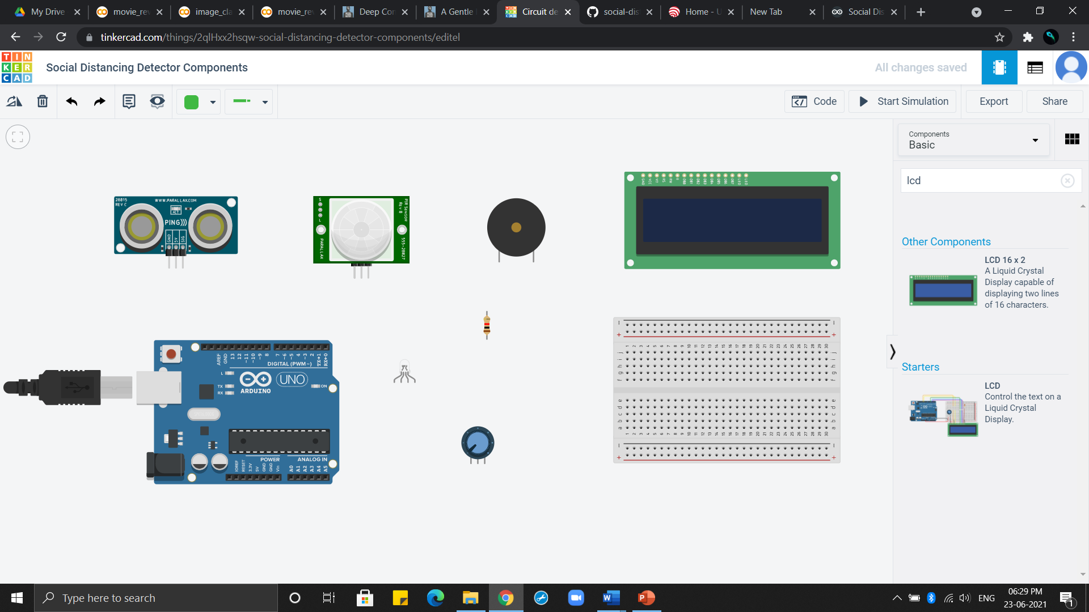

Fig. Circuit Components

**3. Circuit:**

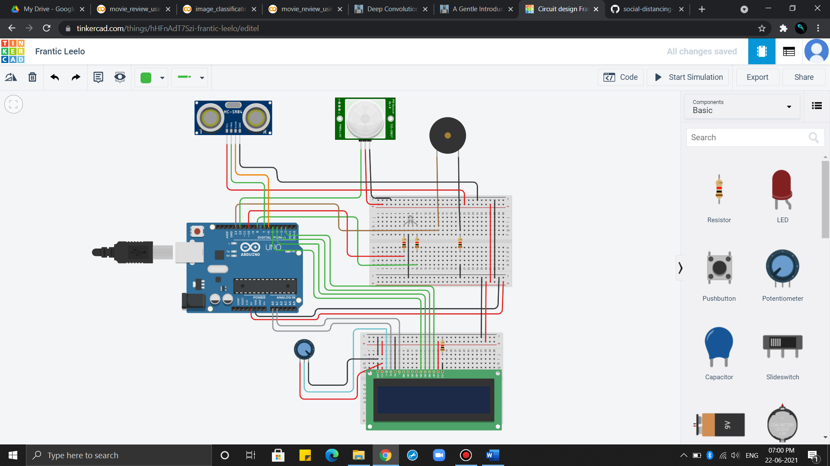

Fig. Social Distancing Detector System

**4. Implementation:**

**4.1 Circuit Implementation-**

1) Select the respective components from the search bar in Tinkercad. Connect them with the breadboard small through connecting wires.

2) Connect piezo, PIR sensor, ultrasonic distance sensor, LCD 16x2 to the Arduino as well as breadboard. Place the LED RGB over one breadboard and LCD display over another, in order to complete the circuit.

3)Code the Arduino by including essential libraries as <liquidcrystal.h>

4)Then provide the logic for calculating distance and display message, glow red color of LED if distance is less than 6 feet.

5)Save the code and start simulation of the circuit and get the output.

**4.2 Code Implementation-**

**4.2.1 Pseudocode:**

* Set pin variable for the buzzer, led and ultrasonic sensor
* Set variables for measurements, duration, and distance
* Set the buzz, trig, led, echo pins to output or input
* Sensor measures distance from itself to object
* If distance < 200cm from moving object

Beep buzzer and glow LED in red color and display message in LCD ‘Stay away’

* If distance > 200cm from moving object

Don’t beep buzzer and glow LED in green color and display message in LCD ‘You are Safe’

* End

**4.2.2 Flowchart:**

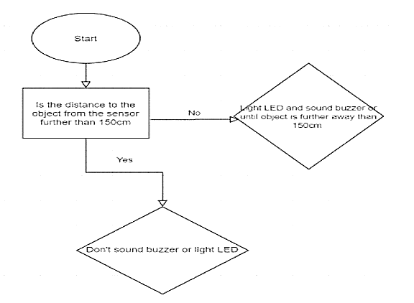

**4.2.3 Code:**

// C++ code

/*

*****This system is used to get alert when any moving entity comes closer to you.

i.e. when distance between you and him is less than 200

*/

//importing library for LCD

#include<LiquidCrystal.h>

//setting function for LCD 16x2. passing arduino pin nos that are connected as parameters.

LiquidCrystal lcd(A0, A1, 5, 4, 3, 2);

//pins connected to ultrasonic distance sensor

int triggerPin = 7;

int echoPin = 6;

//variables

unsigned long duration;

int distance;

//buzzer pin connected to piezo

int pinBuzzer =13;

//pins connected to red color and green color of LED RGB

int rPin =10;

int gPin =8;

//pin connected to PIR sensor

int pirPin =12;

//variable

int isHuman =0;

void setup()

{

//setting pin mode for each of the pins declared above of arduino

//whether pin is for input or output

pinMode(triggerPin, OUTPUT);

pinMode (echoPin, INPUT);

pinMode(pinBuzzer, OUTPUT);

pinMode(rPin, OUTPUT);

pinMode(gPin, OUTPUT);

pinMode(pirPin, INPUT);

//initializing for monitor

Serial.begin(9600);

//initializing LCD 16x2

lcd.begin(16, 2);

}

//we haven't used any function. If functions are used, they must be called within void loop

void loop()

{

//if PIR pin finds any motion, it will be store in isHuman variable

isHuman = digitalRead(pirPin);

Serial.println(isHuman);

if (isHuman ==1){

//when human is present, calculate the distance

digitalWrite(triggerPin, LOW);

delayMicroseconds(2);

//clearing the trigger

digitalWrite(triggerPin, HIGH);

delayMicroseconds(10);

digitalWrite(triggerPin, LOW);

// capturing the time duration for sound wave to travel in microseconds

duration = pulseIn(echoPin, HIGH);

distance = 0.01723 * duration; //formula to calculate distance

Serial.print(distance); //print distance

Serial.println("cm");

if (isHuman == 1 && distance < 200 ){

//when distance is less than 200cm i.e. 6feet, send a message on LCD 16x2, LED RGB will turn red, buzzer/piezo will sound

//LCD RGB will be red

digitalWrite(rPin, HIGH);

digitalWrite(gPin, LOW);

//piezo/buzzer will sound

tone(pinBuzzer,293);

//display message on LCD 16x2

lcd.clear();

lcd.setCursor(0,0);

lcd.print(" STAY!!");

lcd.setCursor(0,1);

lcd.print(" AWAY!!");

//after 200sec stop buzzer/piezo sound, LCD RGB will be off, LCD 16x2 display will be cleared

delay(200);

noTone(pinBuzzer);

digitalWrite(rPin, LOW);

lcd.clear();

}

else {

//if human is present, but distance is more than 200

//LCD RGB will glow green

digitalWrite(rPin, LOW);

digitalWrite(gPin, HIGH);

//LCD 16x2 will show safe message

lcd.setCursor(0,0);

lcd.print(" You are safe");

lcd.setCursor(0,1);

lcd.print(" ");

}

}

}

**5. Working:**

6 feet= 183cm so, we are taking required distance as 200cm.

**5.1 When moving object is at distance more than 200** –

If PIR sensor detects motion of object, then distance is calculated by taking input from ultrasonic distance sensor. If distance between sensor and object is more than 200cm, The LED RGB will glow green light and LCD will display message ‘You are safe’ as well the buzzer will not ring.

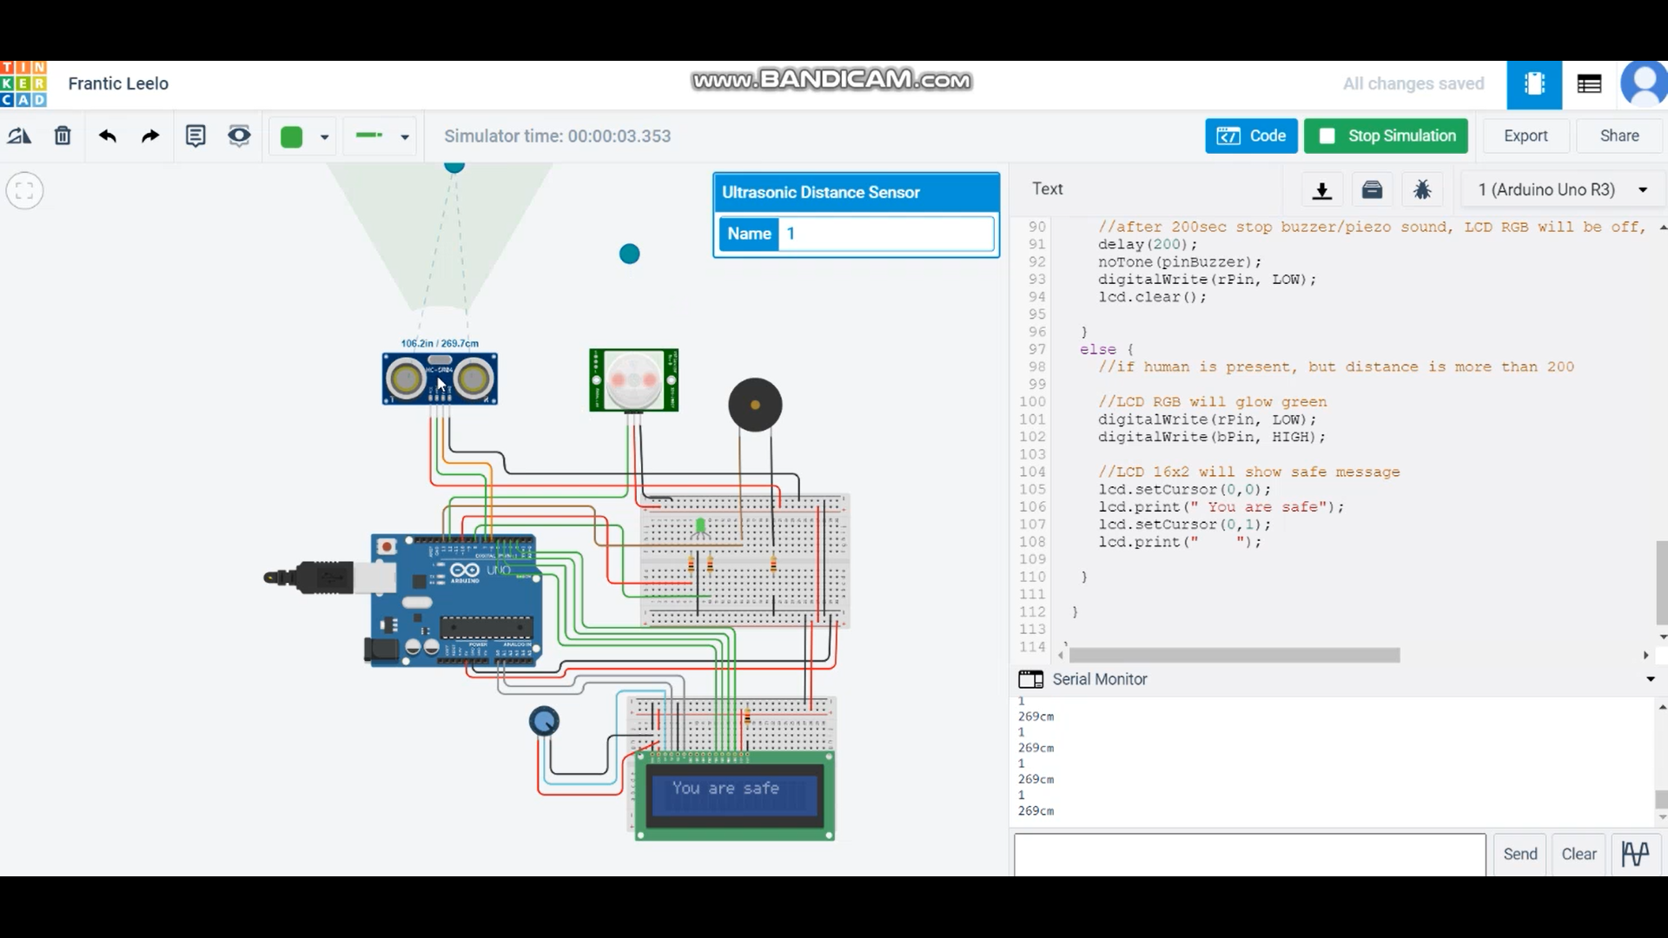

**5.2 when moving object is at distance less than 200** –

If PIR sensor detects motion of object, then distance is calculated by taking input from ultrasonic distance sensor. If distance between sensor and object is less than 200cm, The LED RGB will glow red light and LCD will display message ‘Stay Away’ as well the buzzer will ring for 200sec.

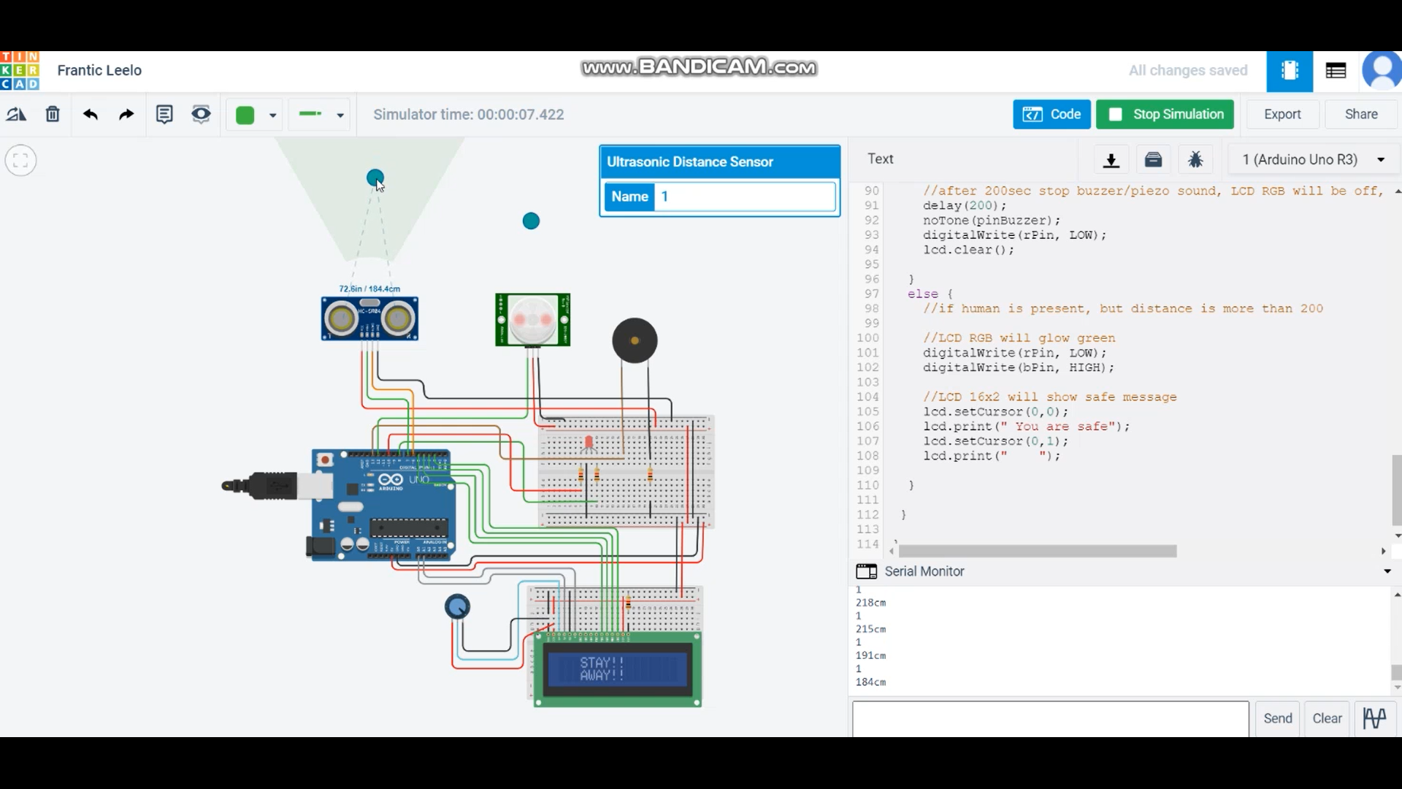

**6. Conclusion:**

We analysed the circuit components and its simulation for Social Distancing Detector system using Arduino. This will prove quite helpful in ensuring social distancing in COVID-19 situation, and safeguard public health.

**7.** **References:**

* <https://www.youtube.com/watch?v=BTEQtmFJsV4>
* <https://github.com/shazforiot/social-distancing-project-using-arduino>
* <https://www.tinkercad.com/>